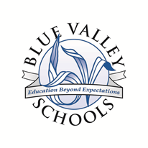
Blue Valley School District

Reading Intervention Program Report
Name:
Date:
Grade Level: 3
Your child has been participating in a reading intervention class using a program called Leveled Literacy Instruction (LLI) in order to develop the skills necessary to meet grade level expectations. In this program, reading skills are assessed regularly. The assessment scores range from Pre-level A (beginning reader) to Level Z (advanced middle school).

Your child began this intervention reading at a Level ____. The most recent assessment shows your child is currently reading at Level ___.

By the end of the year, a typical third grade score is Level P. The chart below shows the target reading goals by month.

Target Reading Levels for Third Grade
Sept.  M/N | Oct.  M/N | Nov.  N | Dec.  N | Jan.  N/O | Feb.  O | Mar.  O | Apr.  O/P | May  P

Comments:

Name
Title
Email

