Intra-district Reading Intervention Transfer Document
Student ___________________________________________ Grade _____________ Date _________________
Reading Specialist ___________________________________ School ___________________________________
Reading Intervention Entrance Date _____________________ Current LLI System ________ Lesson #__________
Latest Reading MAP RIT score (circle one: Fall/Winter/Spring)______________ Percentile_________
Has this student been referred to Level 3? Yes/ No Results________________________________________
______________________________________________________________________________________________
BAS Title | System 1 or 2 | Fiction/Nonfiction | Level | Accuracy | Comprehension | Independent*  (Check one) | Instructional**  (Check one) | Hard***  (Check one) | Self- Correction | Fluency  Levels C-Z | Rate  Levels J-Z(optional) | Writing About Reading (optional)

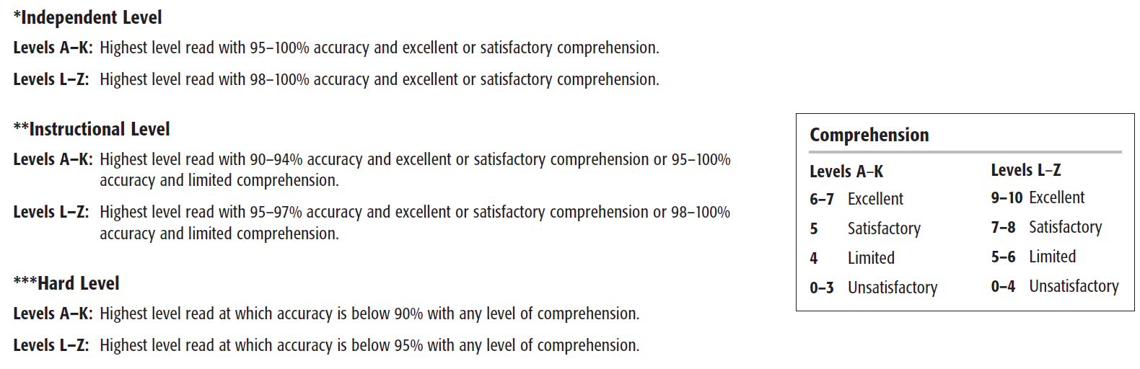
Notes:

